WEB DESIGN PROJECT draft content BLOG

blog page

_________________________________________________________________

TEST LAUNCH WEEK

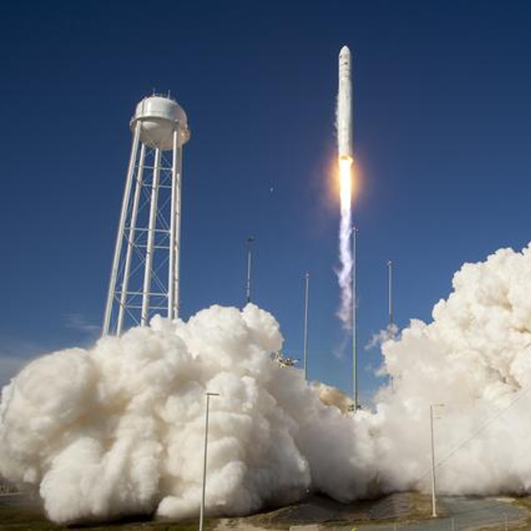

This has been a significant week at Aurora Ireland's launch site in Boa Vista, Brazil. Key team members from Dublin headquarters made their way to the eqautorial location and were in attendance with the Brazilian Ministry of Defence to witness the 1st test launch of IRL1. It's the culmination of more than 2 years of hard work...

**IT'S NOT ROCKET SCIENCE? OH WAIT, IT IS!!**

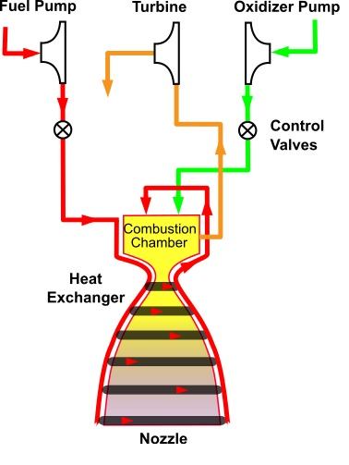

For those who might be interested (and you should be!) here's a piece of actual rocket science. The combustion tap-off cycle is an efficient method we have implemented in our IRL1 rocket, currently undergoing extensive tests. More [details](https://en.wikipedia.org/wiki/Combustion_tap-off_cycle)...

_________________________________________________________________

**THE FULL ORBITAL CYCLE - ARTIST'S IMPRESSION**

We asked the Graphics team at JAM Webdev to put together a vision for us of the full orbital offering coming in 2025. Here is the spectacular result..

{Link to embedded video}